Project 4 - Reflection

Shams Fassassi

5/09/23

CMST 386

Prof. Leslie Allen

## CSS validations:

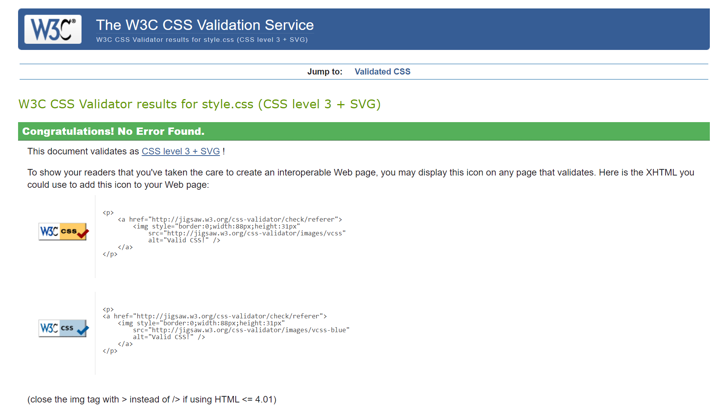

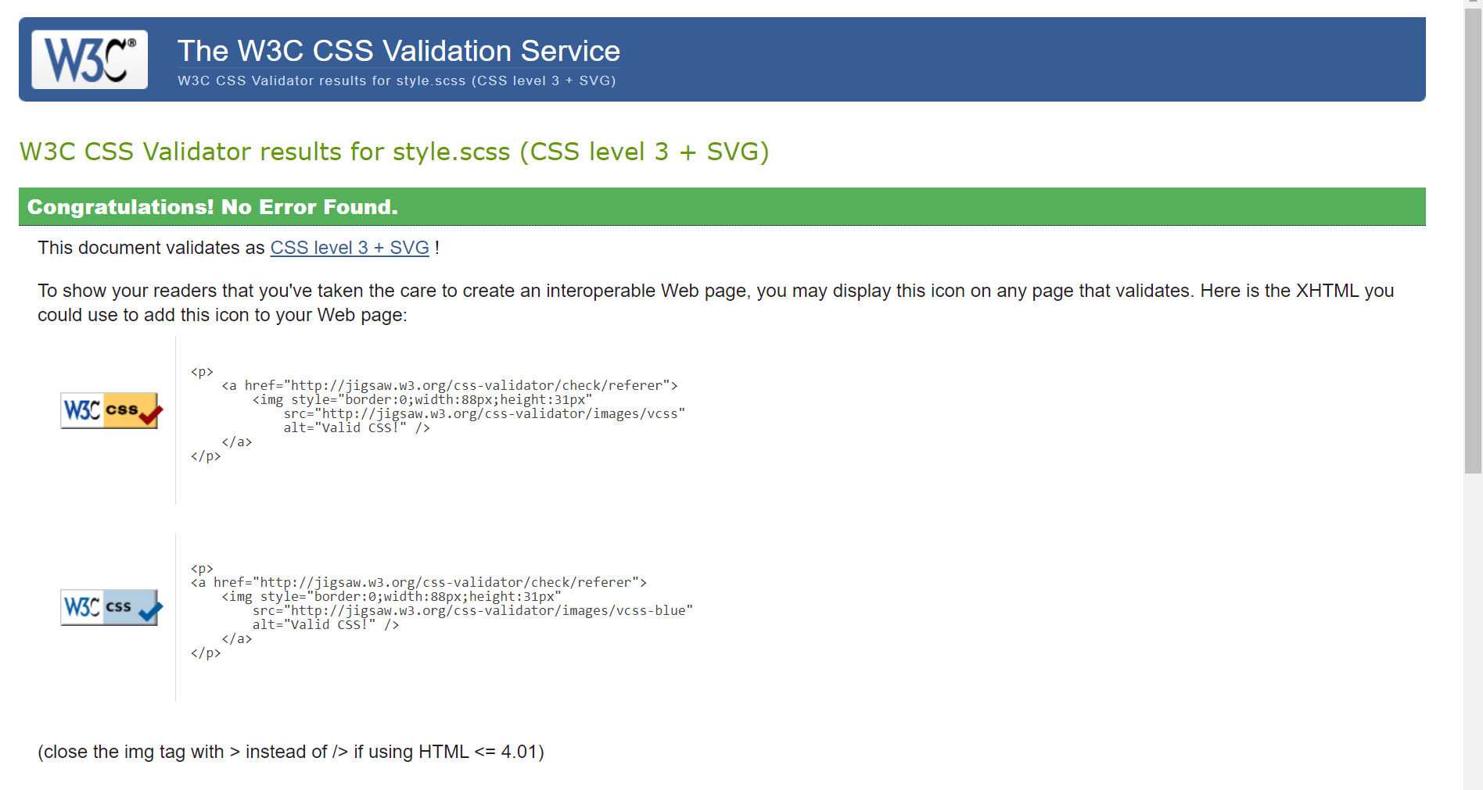

## HTML validations:

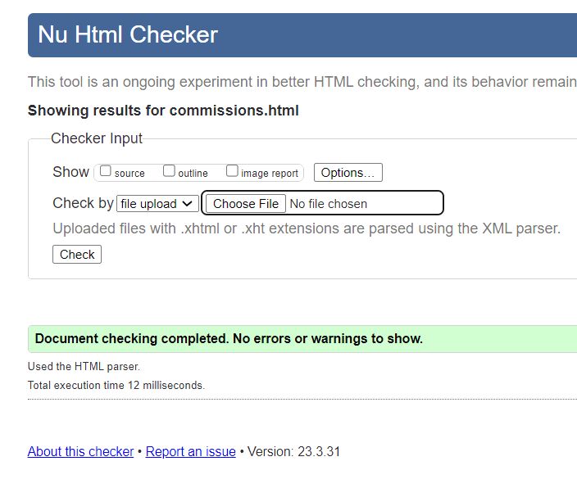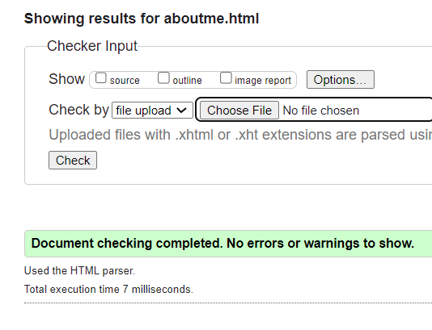

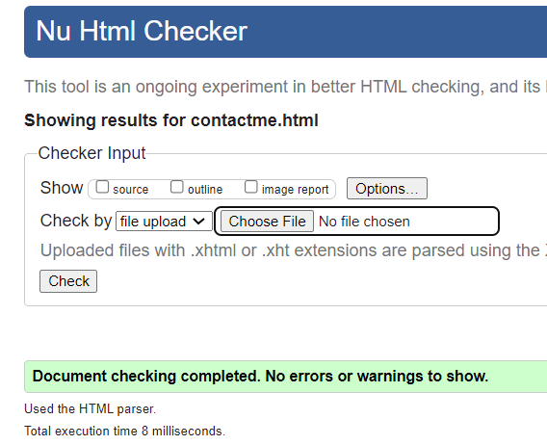

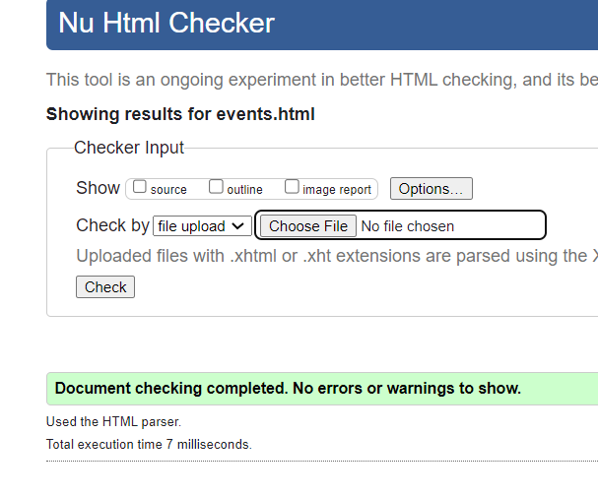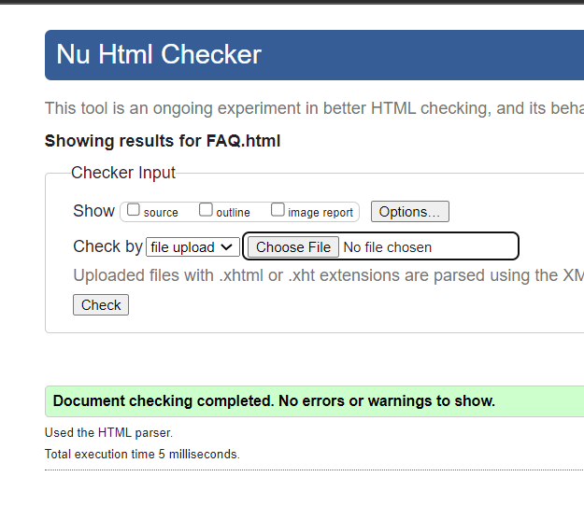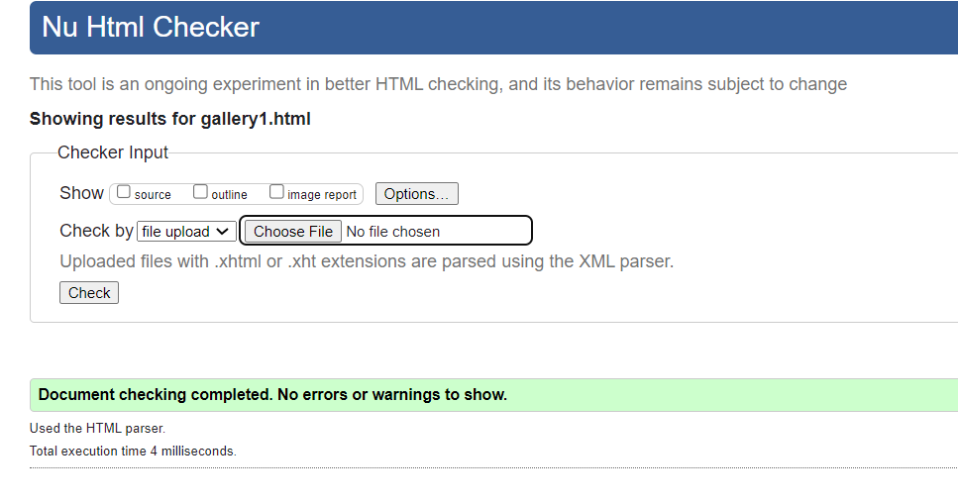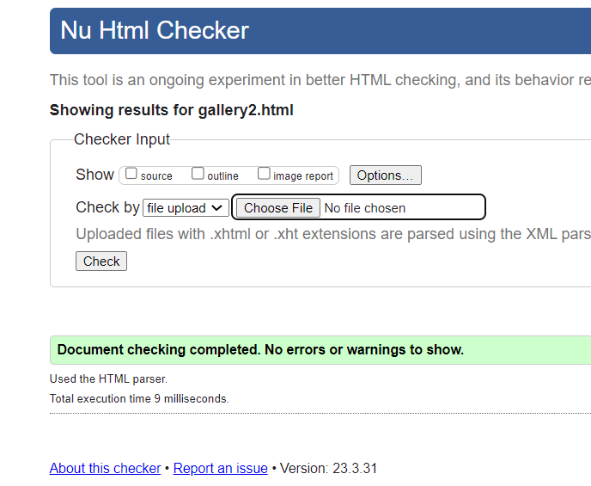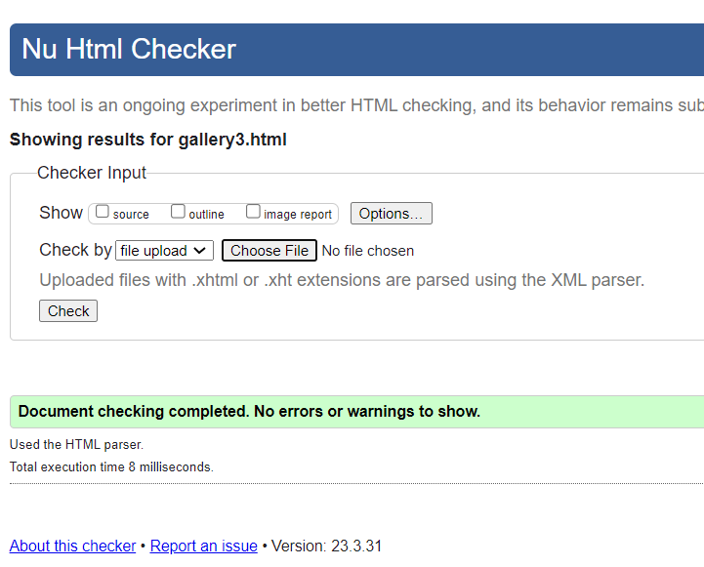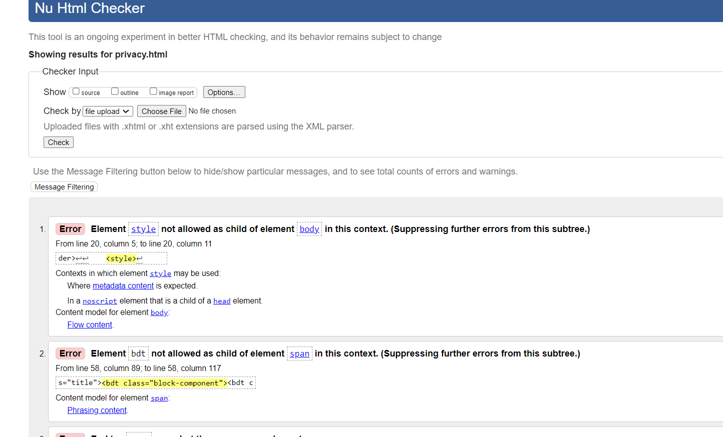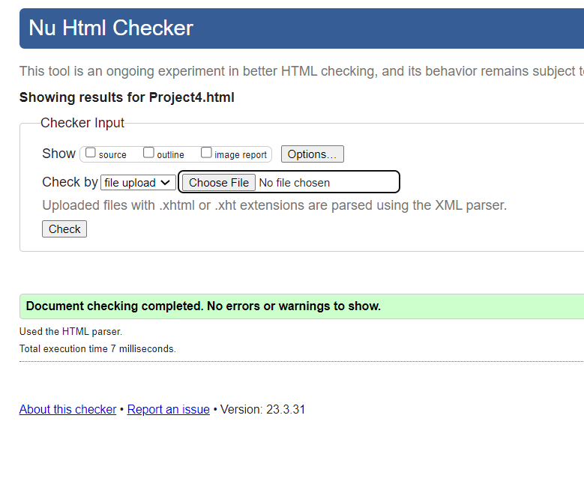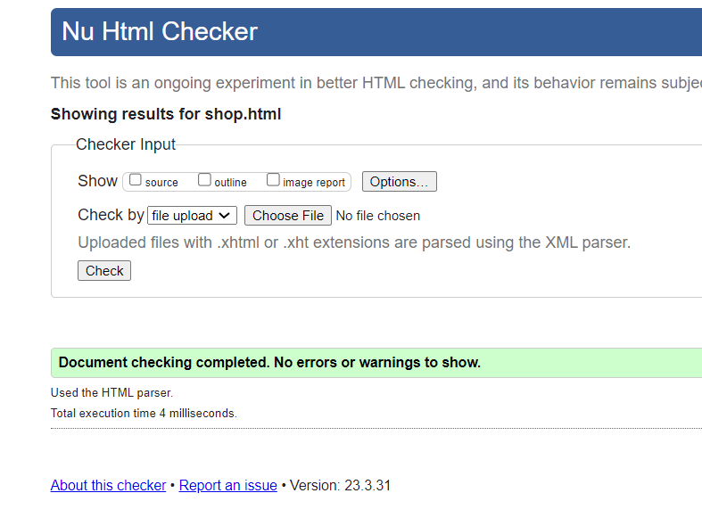

## Project 4 Overview

#### **Developing a favicon that is relevant can be challenging, what did you choose to use for a favicon and why?**

I merely used a pre-existing drawing that works perfectly as an icon. I love it as an icon and it stays on brand with the overall theme of the website.

#### 

#### **One of the fun features of CSS3 is the ability to create movement that attracts the user's attention,how did you decide on the transition feature for this project? Do you feel it attracts the user or creates a distraction?**

The user interfaces I’ve been most attracted to and mesmerized by are the types that I will find in video games. Specifically “pause” menus.

The interface I tried to mimic mostly was that of 1997’s, “Final Fantasy 7”.

I always liked how whatever your cursor was on would be interactive enough to keep you engaged but not distracting to where it takes away from trying to go through the menu.

#### 

#### **What challenges did you face in selecting a hero image for the background of your site? What steps did you take to mitigate these challenges?**

Trying to create a hero image wasn’t as difficult as I thought it would be. However, I did continue to run into an issue where the image wasn’t being linked correctly, which was initially due to the coding software not working, so I had to reset my PC to initiate a fix. Afterwards, the gradient effect wasn’t working well so I had to change and shift how I went about it until I used a linear gradient. Then it wasn’t as difficult.

#### **If you did not face any challenges or issues in completing the project, what do you think are some issues or challenges someone new to creating web pages might face completing a project like this?Note: Your reflection must be a total of at least 250 words.**

I faced many issues. I ran into many with the form page, in terms of how I formatted things and structured things. After a while however, I got into a mode where I seemed to just understand how the form worked based on any form page I’ve ever come across in my internet use. This way I had a clear idea of what attributes meant what and how to use them effectively.

Some ideas I felt I had to attempt to learn quickly in order to implement them, which I'm now realizing is a bit common within the field of coding. It’s okay for me not to remember how to execute every protocol through rote memorization and at the same time it is important for me to do multiple practice runs of a learned concept to become comfortable with coding.

When it came to trying to create animations for images, I became a bit too fixated on that and sizing images properly. From the perspective of CSS I was unsure on how I should order my operators and selectors so that the pseudo-selectors such as :hover worked well and did what I wanted them to do. As of writing this, I’m not 100% sure how I managed to get it to work however it was done through moving things around and constantly debugging.

Where I felt the most comfortable was actually with utilizing transitions and transformations. The way they are formatted is not that much different than when in a video editor such as Sony Vegas or Adobe Premiere.

With this project done, I feel I have a deeper understanding of HTML and CSS especially thanks to SASS. I want to learn to keep my code a lot cleaner or “D.R.Y”. As for javascript, even though I only got a preliminary exposure to it through forms.

The one of the things that nags me a bit is the result I managed to get with the Privacy.html page. This was mainly done from just copy and pasting the privacy policy that was generated in the html format that was offered. However due to how much inline css was generated within that html script I was not sure where to start and end to ensure the validation would be cleared.

## Sitemap

<?xml version="1.0" encoding="UTF-8"?>

<urlset xmlns="http://www.sitemaps.org/schemas/sitemap/0.9" xmlns:xsi="http://www.w3.org/2001/XMLSchema-instance"

xsi:schemaLocation="http://www.sitemaps.org/schemas/sitemap/0.9 http://www.sitemaps.org/schemas/sitemap/0.9/sitemap.xsd">

<url>

<loc>https://CMST386-sfassassi.azurewebsites.net</loc>

<lastmod>2023-05-10</lastmod>

<changefreq>monthly</changefreq>

<priority>0.5</priority>

</url>

<url>

<loc>https://CMST386-sfassassi.azurewebsites.net/project1f/project1.html</loc>

<lastmod>2023-05-10</lastmod>

<changefreq>monthly</changefreq>

<priority>0.5</priority>

</url>

<url>

<loc>https://CMST386-sfassassi.azurewebsites.net/</loc>

<lastmod>2023-05-10</lastmod>

<changefreq>monthly</changefreq>

<priority>0.5</priority>

</url>

<url>

<loc>https://CMST386-sfassassi.azurewebsites.net/project3f/project3.html</loc>

<lastmod>2023-05-10</lastmod>

<changefreq>monthly</changefreq>

<priority>0.5</priority>

</url>

<url>

<loc>https://CMST386-sfassassi.azurewebsites.net/project4f/project4.html</loc>

<lastmod>2023-05-10</lastmod>

<changefreq>monthly</changefreq>

<priority>0.5</priority>

</url>

<url>

<loc>https://CMST386-sfassassi.azurewebsites.net/index.html</loc>

<lastmod>2023-05-10</lastmod>

<changefreq>monthly</changefreq>

<priority>0.5</priority>

</url>

<url>

<loc>https://CMST386-sfassassi.azurewebsites.net/project1.html</loc>

<lastmod>2023-05-10</lastmod>

<changefreq>monthly</changefreq>

<priority>0.5</priority>

</url>

<url>

<loc>https://CMST386-sfassassi.azurewebsites.net/gallery.html</loc>

<lastmod>2023-05-10</lastmod>

<changefreq>monthly</changefreq>

<priority>0.5</priority>

</url>

<url>

<loc>https://CMST386-sfassassi.azurewebsites.net/preprocessing.html</loc>

<lastmod>2023-05-10</lastmod>

<changefreq>monthly</changefreq>

<priority>0.5</priority>

</url>

<url>

<loc>https://CMST386-sfassassi.azurewebsites.net/gallery1.html</loc>

<lastmod>2023-05-10</lastmod>

<changefreq>monthly</changefreq>

<priority>0.5</priority>

</url>

<url>

<loc>https://CMST386-sfassassi.azurewebsites.net/shop.html</loc>

<lastmod>2023-05-10</lastmod>

<changefreq>monthly</changefreq>

<priority>0.5</priority>

</url>

<url>

<loc>https://CMST386-sfassassi.azurewebsites.net/faq.html</loc>

<lastmod>2023-05-10</lastmod>

<changefreq>monthly</changefreq>

<priority>0.5</priority>

</url>

<url>

<loc>https://CMST386-sfassassi.azurewebsites.net/aboutme.html</loc>

<lastmod>2023-05-10</lastmod>

<changefreq>monthly</changefreq>

<priority>0.5</priority>

</url>

<url>

<loc>https://CMST386-sfassassi.azurewebsites.net/privacy.html</loc>

<lastmod>2023-05-10</lastmod>

<changefreq>monthly</changefreq>

<priority>0.5</priority>

</url>

</urlset>